Le petit bateau rouge

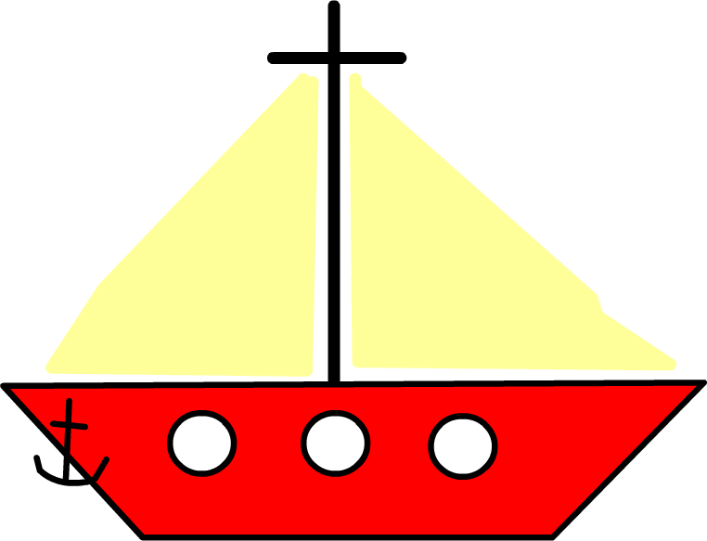

Story Boarding – Word and Sentence Levels

Purpose | - to develop sequencing skills  - to make deductions  - to make judgements informed by reasons and evidence  - to develop language learning strategies and knowledge about language
Links to KS2 framework | - O3.1 Listen and respond to simple rhymes, stories and songs  - O3.2 Recognise and respond to sound patterns and words  - L3.1 Recognise some familiar words in written form  - O4.2 Listen for specific words and phrases  - O4.3 Listen for sounds, rhyme and rhythm  - L4.2 Follow a short familiar text, listening and reading at the same time  - L4.3 Read some familiar words and phrases aloud and pronounce them accurately
Preparation | Pupils work in groups of 3 or 4. Each group will need:  - 1 set of picture cards/Scene base-board + sentence strips
Activities | - Watch the animated on-screen version of the story  - Hand out the pictures and tell the children that they are going to rewatch the story to find the French words for them. Ask pupils to sequence the cards in the order in which they appear in the story.  - As they rewatch, see if the children can identify the French words. Ask them to explain their choice. If word selected is incorrect ask class if there could be another word for the picture. Continue until correct word is identified.  - Once they have identified the words for the pictures, ask them to repeat the words after you. Ask them to comment on the sound and if appropriate the spelling of the words.  - Now ask them to listen to that page being read and to hold up the pictures when they hear the words.  - Now remove the text and ask them to listen again to see if they can identify the words.  - At a later stage the storyboard could be attempted with sentences to match the changing scenes.  - Then ask the children to practice the sentences aloud to perform a puppet theatre production. (Enlarge one of the scenes for a backdrop and enlarge the pictures to make stick puppets.)

 |  | 
 | 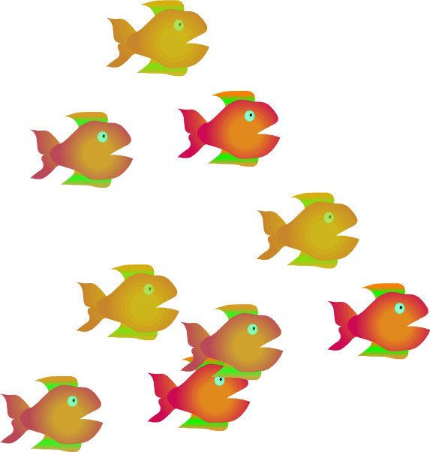 | 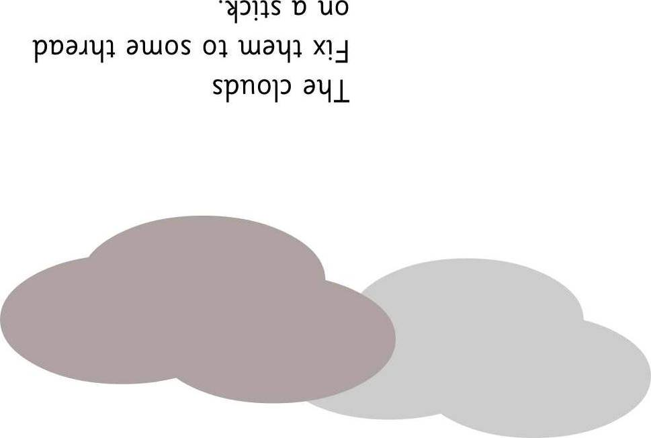
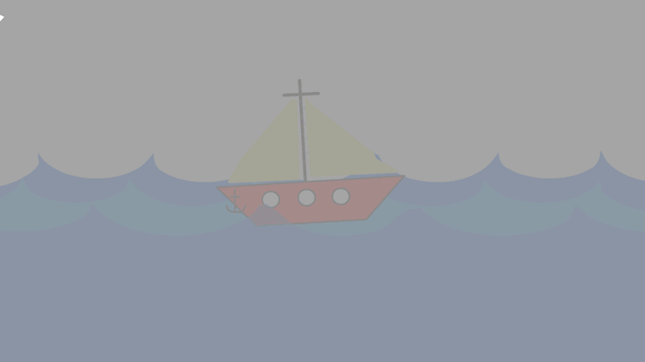 |  | 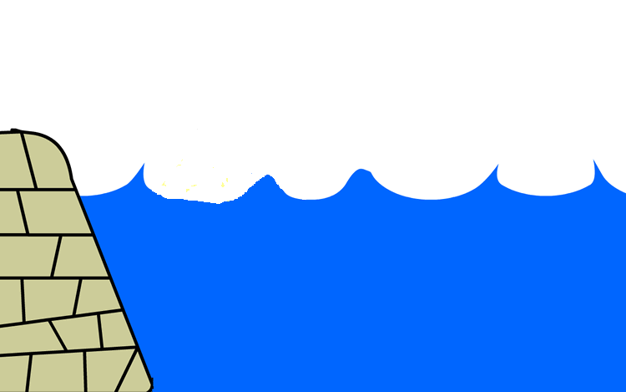

le  bateau | la  mer | les  mouettes
le  soleil | les  poissons | le  nuage
le  brouillard | le  phare | le  port

Card Sorting – Nouns

Purpose | - to sort, classify and group words  - to make links between words  - to develop language learning strategies and knowledge about language
Links to KS2 framework | - O3.2 Recognise and respond to sound patterns and words  - L3.1 Recognise some familiar words in written form  - L3.3 Experiment with the writing of simple words  - O4.2 Listen for specific words and phrases  - L4.3 Read some familiar words and phrases aloud and pronounce them accurately
Preparation | Pupils work in groups of 3 or 4. Each group will need:  - 1 set of noun cards
Activities | - Give out the cards to each group. Say the words on each card and ask them to put them into the sequence as you say them.  - Ask pupils to sort the cards into groups.  - After 5 minutes ask each group how they chose to sort.  - Some groups will probably sort by “le”, “la” and “les”. Ask pupils to explain what the “le”, “la” and “les” could mean and consequently to articulate precisely how they have sorted – i.e. by gender. Gender is a difficult concept for English speakers, give pupils time to reflect on the concept.  - Ask other groups to comment.  - Once the children are familiar with recognizing the written words they could use the picture and word cards to play vocabulary games such as pelmanism.  - Use the pictures with magnets to play a fishing game. A child fishes out a picture and says the word in French before sorting it according to le la les or whether it contains a particular phonic sound eg oi eau ou

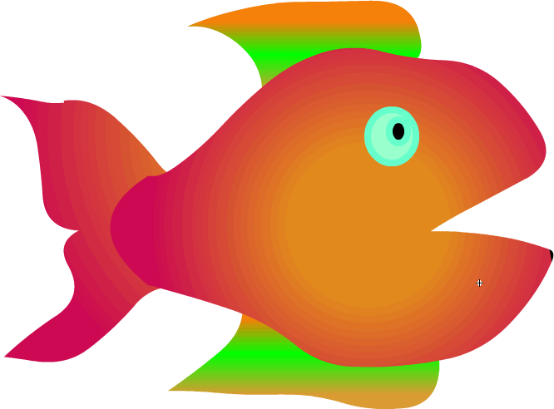

le

la

les

oi

eau

ou

Cherchez l’intrus

Choisis l’intrus sur chaque ligne et explique ton choix.

1 | petit | le soleil | les poissons | le port
2 | la mouette | la mer | le bateau | rouge
3 | bleu | la mer | le ciel | le soleil
4 | le nuage | les mouettes | le soleil | le brouillard

Cherchez l’intrus

Choisis l’intrus sur chaque ligne et explique ton choix.

1
2
3
4 |  | 1

Le petit bateau rouge est perdu

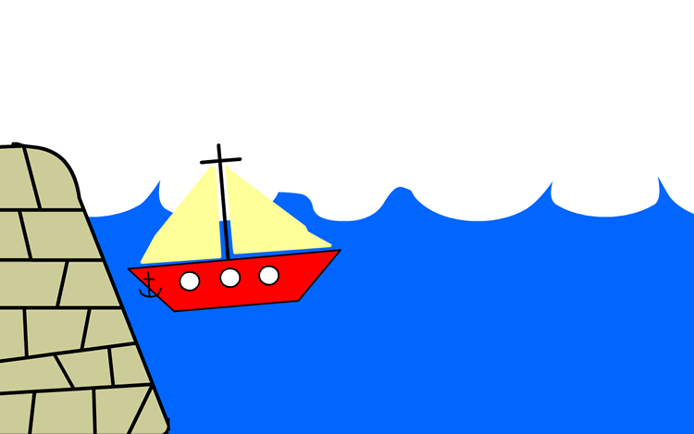 | 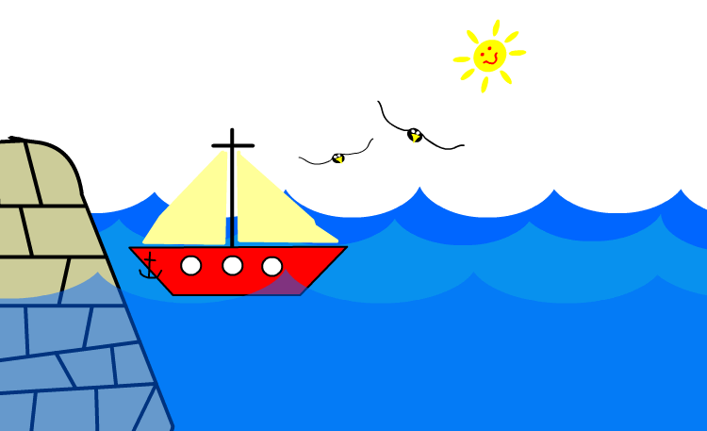 | 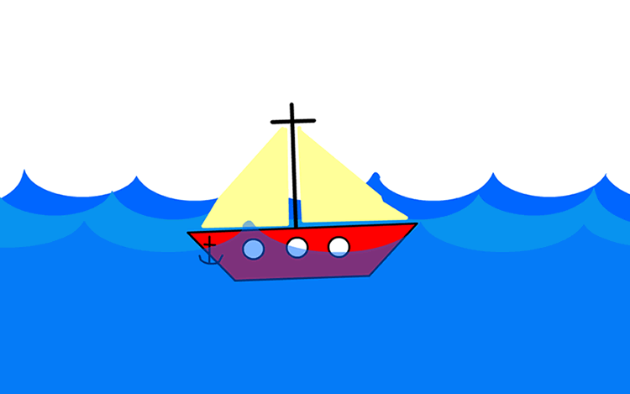 | 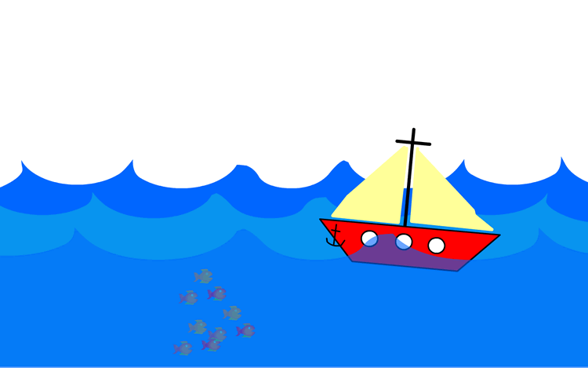
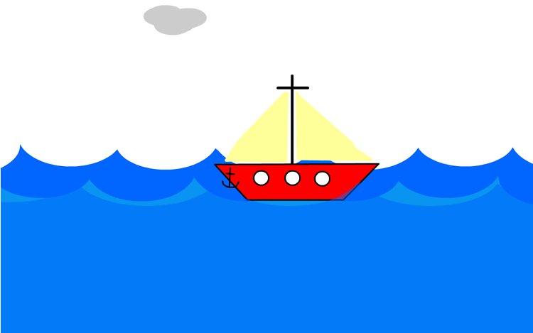 |  | 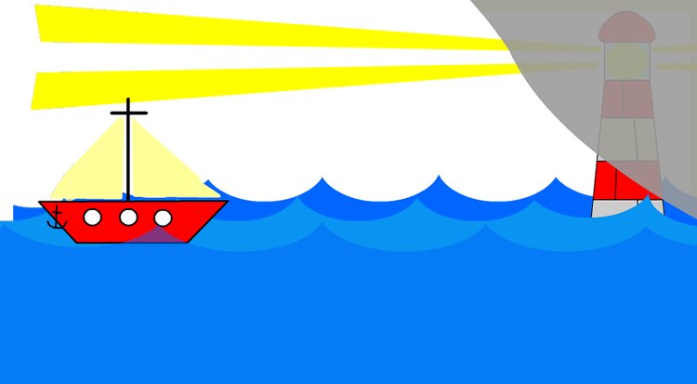 | 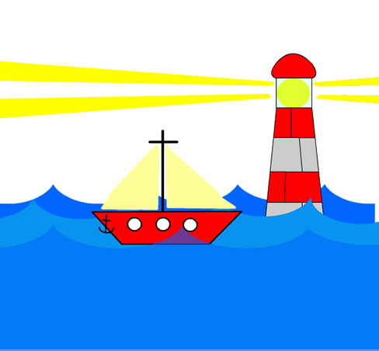

Petit bateau rouge était au port. | «Viens jouer! » ont dit les mouettes. | Petit bateau rouge est parti en pleine mer. | «Ne vas pas trop loin, » ont dit les poissons.
«Ne vas pas trop loin, » a dit le nuage. | Petit bateau rouge était perdu dans le brouillard. | «Viens me voir,» a dit le gentil phare. | «Merci,» a dit Petit bateau rouge

Petit bateau rouge était au port. | «Viens jouer! » ont dit les mouettes. | Petit bateau rouge est parti en pleine mer. | «Ne vas pas trop loin, » ont dit les poissons.
«Ne vas pas trop loin, » a dit le nuage. | Petit bateau rouge était perdu dans le brouillard. | «Viens me voir,» a dit le gentil phare. | «Merci,» a dit Petit bateau rouge

